Autofocusing in Fourier Ptychographic Microscopy
A Literature Review and a Modulation-Depth Theory for Phase-Object Defocus Estimation
Gaurang Garg — Healthcare Optics Research Group (H-ORG), Centre for Biomedical Engineering, IIT Delhi
Review Article, July-August 2026

Abstract
Fourier ptychographic microscopy (FPM) reconstructs a wide-field, high-resolution, quantitative-phase image of a sample from many angle-varied low-resolution captures, and can digitally correct for defocus as part of its pupil-function recovery. Every account of this capability, from the original 2013 demonstration through the two most comprehensive reviews of the field, treats defocus estimation itself -- deciding how far out of focus a set of raw captures actually is, before or during reconstruction -- as a secondary, largely solved detail: sweep a candidate defocus value, reconstruct, and pick the sharpest result. This review surveys the literature that has grown up around that step specifically, for FPM and for phase-object autofocusing more broadly, and finds a consistent pattern: sharpness-search, residual-consistency, hardware-assisted, and learned single-shot methods have all been proposed and shown to work in specific configurations, but no prior work derives, from first principles, why a simple sharpness search behaves the way it does on a phase object, nor identifies the specific numerical and physical pitfalls -- an intensity-normalization bug, an unenforced propagation sampling limit, and a mistaken assumption that raising visual contrast improves noise robustness -- that can silently compromise it. We connect this literature to an extensive simulation study of our own, built around a single governing concept we call modulation depth, and show that it explains several previously separate observations in the literature (the noise-to-resolution tradeoff in transport-of-intensity phase imaging, the illumination-NA matching condition in differential phase contrast, and the success of learned off-axis-illumination autofocus over naive sharpness search) as manifestations of one underlying quantity. We close by proposing that the objective NA at which a system's diffraction limit is critically matched to its camera's Nyquist sampling limit is also the NA that maximizes single-shot autofocus noise robustness for a phase object -- a connection that, to our knowledge, has not been made explicitly before -- and we catalog the specific gaps this review identifies as concrete future work.

1. Introduction
Fourier ptychographic microscopy (FPM) was introduced by Zheng, Horstmeyer, and Yang in 2013 as a way to give an ordinary, low-magnification microscope objective both the wide field of view of a low numerical aperture (NA) lens and the resolution of a high-NA one, by combining many images captured under sequentially varied LED illumination angles into one synthesized, high-resolution Fourier spectrum (Zheng, Horstmeyer & Yang, 2013). In the twelve years since, FPM has grown from a single laboratory demonstration into a mature computational-imaging framework, surveyed comprehensively by Pan, Zuo, and Yao (2020) in Reports on Progress in Physics and by Zheng, Shen, Jiang, Song, and Yang (2021) in Nature Reviews Physics -- two reviews that together catalog several hundred variants, applications, and algorithmic refinements of the core method.
Buried inside this large literature is a smaller, less examined problem: before FPM's iterative reconstruction can succeed, the system needs a reasonably accurate estimate of how far the sample was from true focus when the raw images were captured. Both major reviews, and the original paper itself, discuss defocus correction as something FPM can do computationally, treating it as one aberration term among several that the pupil-recovery process handles -- but neither offers a first-principles account of why the specific strategy usually invoked to find that defocus value in the first place (sweep candidate values, reconstruct, keep the sharpest) should or should not be trusted, especially for the transparent, unstained phase objects that are FPM's most important biomedical target. This review has two aims. First, we survey the literature on autofocusing in FPM specifically, and on phase-object autofocusing more broadly, tracing how the field has approached the defocus-estimation problem across sharpness-search, pupil-fitting, hardware-assisted, and learned single-shot methods. Second, we connect that literature to an extensive, adversarially-tested simulation study of our own, and show that a single concept -- the relative modulation depth of a sharpness metric across a defocus sweep -- both explains gaps in the existing literature and predicts a specific, testable, and to our knowledge novel optical design consequence.

2. Fourier Ptychographic Microscopy: The Established Picture
FPM places a low-NA objective lens over a sample illuminated in turn by each element of an LED array beneath it. Illuminating from an angle rather than straight on shifts which part of the sample's spatial-frequency spectrum falls inside the lens's limited passband; capturing one low-resolution image per illumination angle and iteratively stitching these shifted, overlapping passband patches together in Fourier space synthesizes a spectrum far larger than the physical lens could deliver in one exposure (Zheng, Horstmeyer & Yang, 2013). The resulting synthetic NA is set by NA_illumination + NA_objective rather than by the objective alone -- a revision to the classical Abbe resolution formula significant enough that, as Pan, Zuo, and Yao (2020) note, it has since been written into the fourth edition of Goodman's Introduction to Fourier Optics (Goodman, 2017), the standard reference for the underlying wave-optics formalism used throughout this review and our own prior work.
Zheng, Shen, Jiang, Song, and Yang (2021) formalize the relationship between FPM and the closely related technique of real-space ptychography: both iteratively recover a complex object consistent with many intensity measurements, but FPM imposes its support constraint (the pupil aperture) in the Fourier domain while real-space ptychography imposes it (a confined illumination probe) in the spatial domain -- a duality the authors describe as FPM being 'the Fourier counterpart' of ptychography. Pan, Zuo, and Yao (2020) catalog the resulting family of algorithms -- alternating projection, embedded pupil-function recovery (EPRY-FPM), Wirtinger-flow and Gauss-Newton optimization, and momentum-based variants -- along with 3D extensions via multi-slice modeling and diffraction tomography, and a long list of biomedical applications from digital pathology to high-content cytometry.
Defocus enters this picture as a specific, simple case of a more general pupil-plane aberration: multiplying the pupil function by exp[i*z0*kz(kx,ky)], exactly the angular-spectrum propagation phase discussed in Fourier-optics terms throughout our own project, refocuses the reconstruction to an assumed distance z0 from the nominal focal plane (Zheng, Horstmeyer & Yang, 2013). Because this correction is just one more multiplicative term in the existing pupil-recovery machinery, both reviews treat 'digital refocusing' as a solved capability of FPM, with Zheng et al. (2021) stating as a key point that 'defocus is a type of aberration and, thus, FP can computationally refocus images over a much extended range.'

3. How the FPM Literature Has Approached Finding the Defocus Value Itself
Digitally correcting a known defocus is a different problem from discovering an unknown one, and it is on this second, narrower problem that the literature is thinner and more fragmented. We group the approaches we found into five families.

3.1 Sharpness search, as originally proposed
The original FPM paper addresses the unknown-defocus case directly, if briefly: 'If the defocus distance is unknown, we can digitally adjust the z parameter to different values, reconstruct the corresponding FPM images, and pick the sharpest image through observation or by a computer algorithm' (Zheng, Horstmeyer & Yang, 2013). This sentence is, as far as we can establish, the origin of the entire greedy sharpness-search strategy for FPM autofocus -- and it is proposed without specifying which sharpness metric to use, without any noise-budget analysis, and without discussion of how far the z sweep can safely extend before the propagation calculation itself becomes unreliable. Our own project's central results (Sections 5-6 below) speak directly and specifically to this one sentence.

3.2 A residual-consistency autofocus index (the original patent family)
A related but conceptually distinct metric appears in the FPM patent family associated with the original inventors: an 'auto-focusing index' defined as the reciprocal of the summed absolute difference between the simulated low-resolution amplitude image and the actual low-resolution measurement, summed across all illumination angles (Zheng, Yang et al., patent family, e.g. US 9,892,812; US 10,679,763; US 12,237,094). This is worth distinguishing carefully from a Brenner-style sharpness gradient: it measures how well a candidate reconstruction, forward-simulated back through the pupil at each illumination angle, agrees with everything that was actually measured -- a cross-angle consistency check -- rather than measuring the sharpness of a single reconstructed image directly. To our knowledge, no published comparison quantifies the relative noise robustness of these two metric families against each other for phase objects specifically.

3.3 Defocus as a fitted Zernike mode in joint pupil recovery
EPRY-FPM and its descendants recover the pupil function jointly with the object, and can decompose the resulting phase into Zernike polynomial coefficients, of which one mode corresponds to defocus (Pan, Zuo & Yao, 2020, summarizing Ou, Zheng & Yang, 2014; Song et al., 2019). This approach folds defocus estimation into the same joint optimization that corrects other aberrations, sidestepping an explicit sharpness search, but Pan, Zuo, and Yao (2020) list, among their catalog of open problems, that 'it is unclear whether the retrieved aberration is right or not and whether the aberration is the summation of all the system errors' -- an acknowledgment that the reliability of this defocus-as-aberration approach under realistic noise is itself unresolved in the mainstream literature.

3.4 Hardware-assisted single-frame focus detection
A separate line of work sidesteps sharpness search entirely with additional optics. Two-pinhole or dual-LED illumination creates a laterally shifted image pair within a single captured frame; the shift between the pair, measured by phase correlation, directly encodes defocus distance by the same phase-detection-autofocus principle used in consumer camera sensors, and can span a focal range orders of magnitude larger than the objective's native depth of field from one frame (Liao et al., 2016, 2017; Guo et al., 2020, OpenWSI). This family trades an added optomechanical component for a defocus estimate that does not depend on any sharpness assumption about the reconstructed image at all.

3.5 Learned, single-shot defocus prediction
A fourth family trains a neural network to predict defocus directly from one captured image, without any axial sweep. Jiang et al. (2018) trained convolutional networks on roughly 130,000 labeled whole-slide images under three illumination coherence settings, and report explicitly that 'solely relying on spatial information leads to a relatively bad performance' -- transform-domain (Fourier) and multi-domain features were needed for reliable single-frame prediction, and performance depended on the illumination coherence setting used. Pinkard, Phillips, Babakhani, Fletcher, and Waller (2019) add one or a few off-axis LEDs to a conventional microscope and train a small 'fully connected Fourier neural network' on the Fourier-transform magnitude of a single obliquely-illuminated image; their saliency analysis shows that the edges of the object's spectrum -- high-angle scattered light that is present off-axis but not captured on-axis at large defocus -- carry the dominant defocus signal, and that a network trained on Fourier magnitude outperforms one trained on Fourier phase. Related single-shot approaches extend this to holographic and general microscopy autofocus (Luo, Huang, Rivenson & Ozcan, 2020) and to lightweight real-time networks for augmented-reality microscopes (cited in the deep-learning single-shot autofocus literature reviewed here), the latter of which explicitly notes that focusing accuracy degrades as objective NA shrinks toward low-magnification regimes.

3.6 Blind digital refocusing as a reconstruction byproduct
Most recently, feature-domain backdiffraction methods have been reported to achieve 'automatic blind-digital refocusing without a prior defocus distance' as a side effect of a reconstruction algorithm designed primarily to reduce vignetting artifacts and relax the need for precisely known LED positions (FPM-WSI, 2024 preprint). This demonstrates that blind refocusing is achievable in a full system context, but, consistent with the pattern across this entire literature, without a first-principles account of the noise conditions under which the blind refocusing might or might not succeed.

3.7 Summary of the gap
Table 1 summarizes these five families. Read together, they show a field that has repeatedly worked around the defocus-estimation problem -- with better hardware, joint optimization, or learned regressors -- more often than it has analyzed the original, simplest proposal (greedy sharpness search) on its own terms. Our own project is, in this sense, an attempt to finally answer the question the 2013 paper's one sentence left open.
Family | Core idea | Representative work
Sharpness search (original) | Sweep z, reconstruct, keep sharpest | Zheng et al. 2013
Residual-consistency index | Cross-angle forward-simulation agreement | FPM patent family
Zernike-fitted defocus | Joint pupil/object recovery, defocus as one aberration mode | Ou, Zheng & Yang 2014; Pan et al. 2020
Hardware-assisted single-frame | Dual-pinhole/LED phase-detection shift | Liao et al. 2016/2017; Guo et al. 2020
Learned single-shot | CNN/FCFNN predicts z from one frame | Jiang et al. 2018; Pinkard et al. 2019; Luo et al. 2020
Blind reconstruction byproduct | Feature-domain backdiffraction | FPM-WSI 2024

4. Autofocusing and Focus Detection for Phase Objects Beyond FPM
FPM's defocus problem is a specific instance of a much older, more general difficulty: focusing on an object that is nearly invisible to intensity-only detection exactly at focus. Three bodies of work outside the FPM literature bear directly on this.

4.1 Transport of intensity and depth-from-defocus
The Transport of Intensity Equation (TIE), first solved by Teague (1983), relates the axial derivative of intensity to the Laplacian of phase -- exactly the mechanism our own project uses to explain why a phase object's contrast grows with defocus before conventional blur takes back over. A body of work explicitly unifies TIE with the older computer-vision technique of depth-from-defocus, showing, via the Wigner distribution function, that the two are special cases of one another and that the level of spatial coherence is 'the driving factor' in which regime dominates (Depth from Defocus as a Special Case of the Transport of Intensity Equation, IEEE conference literature). This is a direct, independently-derived precedent for our own finding that illumination coherence (on-axis versus oblique) changes the character of the defocus-to-intensity relationship, not merely its magnitude.

4.2 Differential phase contrast, the weak-object transfer function, and a named noise-resolution tradeoff
Tian and Waller (2015) derive the two-dimensional weak-object transfer function (WOTF) for asymmetric-illumination differential phase contrast (DPC) on an LED array microscope -- the same hardware platform FPM uses -- and show the phase transfer function is anti-symmetric and exactly zero along the axis of illumination symmetry, requiring multiple illumination angles for stable recovery. Later work extending TIE to partially coherent, annular illumination goes further and explicitly names the tradeoff we independently rediscovered: increasing illumination NA (reducing spatial coherence) extends achievable resolution but 'exacerbates the noise-to-resolution tradeoff... because the decrease in illumination coherence tends to attenuate the phase effect,' since the phase transfer function 'goes to zero rapidly as the spatial frequency decreases in the small-defocus regime.' A closely related 2020s paper on DPC beyond the weak-object approximation notes separately that DPC 'requires strict matching of the illumination NA to ensure complete transmission of low-frequency information.'

4.3 Classic, contrast-mode-dependent focus-metric comparisons
Long before FPM existed, Sun, Duthaler, and Nelson (2004) compared eighteen published focus algorithms -- derivative-based, statistical, correlation-based, and frequency-based -- across bright-field, phase-contrast, and DIC illumination on the same biological samples, finding no single algorithm universally best and noting that derivative-based (Brenner-family) algorithms assume well-focused images carry more high-frequency content, an assumption that does not transfer cleanly across contrast modes. An earlier line of patented work from the early 1990s had already established, empirically, that phase-contrast images give higher-contrast autofocus signals than brightfield for unstained cells specifically, motivating phase contrast as a practical, non-photobleaching proxy for true (fluorescence) focus (Price et al., patent family).

5. What This Literature Has Not Yet Connected
Reading these two bodies of work side by side -- FPM-specific autofocus engineering, and the older phase-object/TIE/DPC theory -- exposes a set of connections that, as far as our search has been able to establish, no single prior publication makes explicitly:
- No paper we found identifies or corrects a per-frame intensity-normalization step in a Brenner-style FPM sharpness metric, despite this being exactly the kind of implementation detail (rescaling each candidate reconstruction before measuring its gradient) that our own work shows can manufacture spurious curve structure specifically for phase objects, whose true in-focus signal can be several orders of magnitude below the sweep's peak value.
- No paper derives or enforces the angular-spectrum sampling (aliasing) bound on FPM's own pupil-plane defocus phase factor when refocusing over an extended range, despite Zheng et al. (2013) and Zheng et al. (2021) both describing extended-range digital refocusing as a standard FPM capability; the band-limited correction needed to do this safely (Matsushima & Shimobaba, 2009) belongs to the computational-Fourier-optics literature, not the FPM literature, and the two have not been connected in print.
- No paper directly tests, and to our knowledge falsifies, the specific hypothesis that oblique or off-axis illumination improves noise-robust GREEDY sharpness-based autofocus for a phase object. Pinkard et al. (2019) succeed with off-axis illumination, but only via a trained regressor operating on Fourier-magnitude features, not a scalar sharpness search; our result that a naive Brenner-gradient search gets WORSE under oblique illumination, even as a trained network using the same illumination geometry succeeds, is a distinction not previously drawn out, and reconciles what would otherwise look like a contradiction between our results and theirs.
- No paper connects the illumination-NA-matched-to-objective-NA condition well known in DPC/WOTF theory (Tian & Waller, 2015; subsequent DPC literature) to the separately well-known objective-NA-matched-to-camera-Nyquist condition from general microscope design practice, as jointly predicting a single optimal NA for single-shot autofocus signal depth specifically.
- The FPM patent family's own residual-consistency autofocus index has never, to our knowledge, been quantitatively compared against a Brenner-gradient sharpness metric for noise robustness on phase objects -- a direct, concrete piece of future work this review identifies but does not itself resolve.

6. Our Contribution: A Modulation-Depth Theory, Tested Adversarially
Building on this literature, and using the canonical FPM optical parameters and object models described in our companion methods report, we ran an extensive series of simulation experiments designed, wherever possible, to falsify our own emerging conclusions rather than merely confirm them. The results below are summarized here in the context of the literature just reviewed; full derivations, figures, and numerical results appear in our companion reports.

6.1 The metric-definition pitfall (extending Sun et al.'s contrast-mode caveat to FPM)
Directly in the spirit of Sun, Duthaler, and Nelson's (2004) finding that focus-metric behavior does not transfer cleanly across contrast modes, we found that a single contrast mode (coherent, on-axis phase imaging) can itself produce two incompatible sharpness curves depending on an easily-overlooked implementation choice: rescaling each candidate defocus plane's intensity to a fixed range before computing a Brenner gradient, versus not rescaling. The true physical contrast at focus for a weak phase object was only about 0.025% of the sweep's peak value; the rescaled metric erased this three-order-of-magnitude difference and manufactured a spurious double-peak structure the unscaled metric did not show.
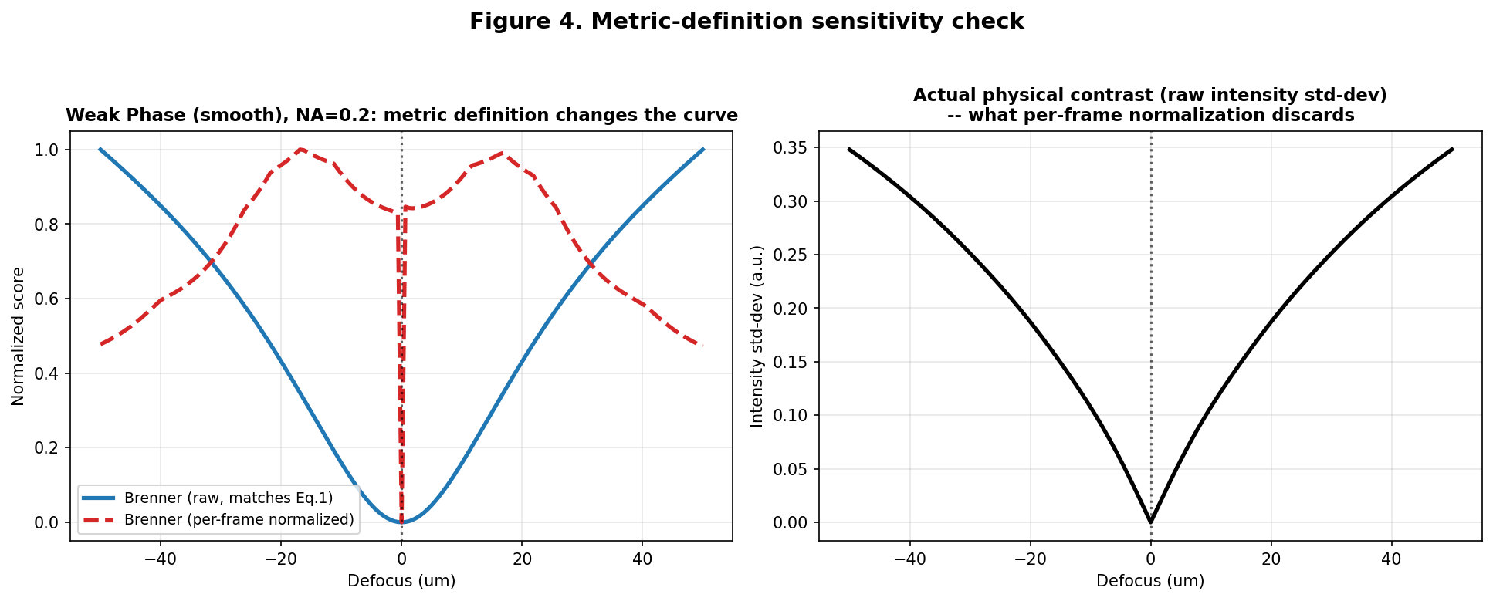
Figure 1. Raw vs. per-frame-normalized Brenner curves for identical underlying data (left), and the true, unscaled physical contrast the normalization step discards (right). This is the kind of contrast-mode-dependent metric fragility Sun et al. (2004) documented across bright field/phase/DIC, now shown to occur within a single (coherent, FPM-style) illumination mode depending purely on an implementation detail.

6.2 Noise fragility as an instance of the TIE noise-to-resolution tradeoff
Consistent with the noise-to-resolution tradeoff named explicitly in the annular-illumination TIE literature reviewed in Section 4.2, we found that even at generous photon budgets (5,000 photons/pixel), single-shot success at recovering true focus for a phase object was well under 50%. We then tested, and falsified, two independently reasonable fixes. Splitting a fixed total photon budget across more illumination frames provided no systematic benefit (a direct consequence of Poisson statistics, confirmed empirically). More importantly, oblique illumination -- chosen because it is known from the DPC/WOTF literature (Tian & Waller, 2015) to convert phase gradients into visible contrast even at zero defocus -- raised the raw, single-frame intensity contrast at focus by roughly 500-fold, yet made greedy sharpness-based autofocus reliability worse, not better, at every matched photon budget.
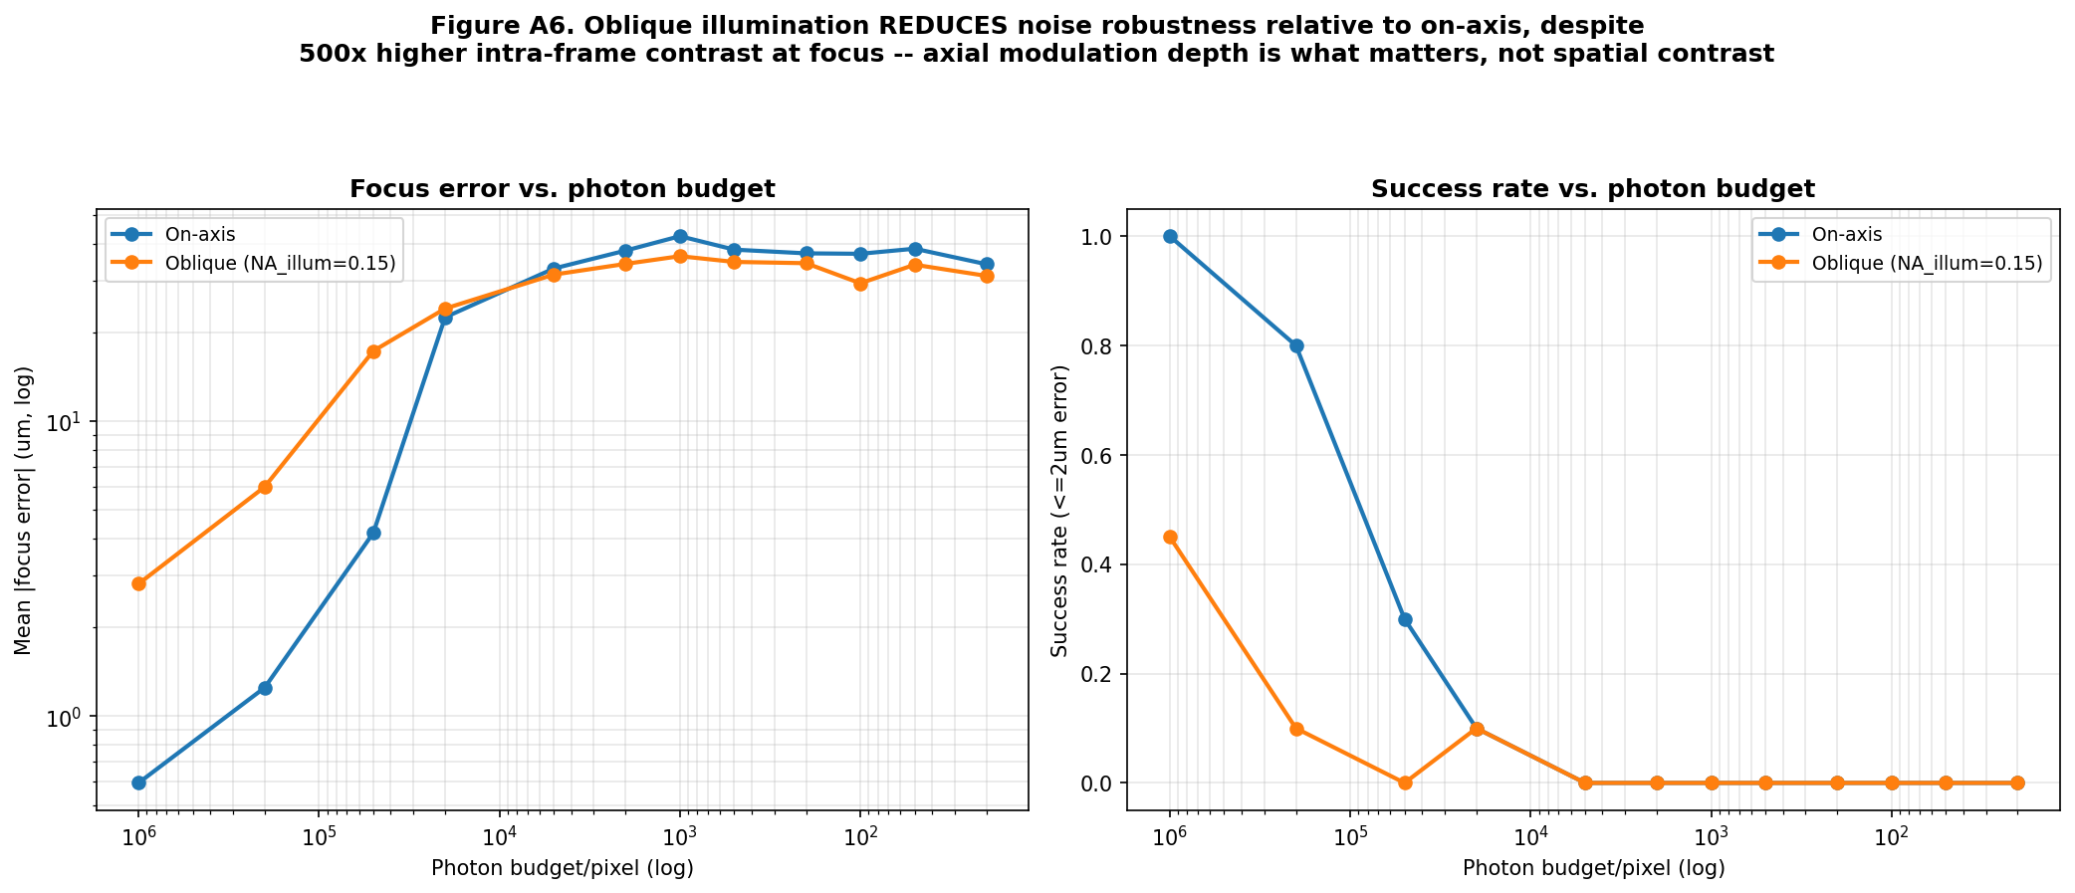
Figure 2. On-axis illumination recovers true focus at far lower photon budgets than oblique illumination, despite oblique illumination's much higher raw spatial contrast. This is the result that must be reconciled with Pinkard et al.'s (2019) success using oblique illumination -- resolved in Section 6.3.

6.3 Reconciling our result with Pinkard et al. (2019): greedy search versus learned estimation
At first reading, our finding that oblique illumination worsens sharpness-based autofocus appears to conflict with Pinkard et al.'s (2019) demonstration that oblique illumination enables accurate single-shot defocus prediction. The conflict resolves once the estimator is distinguished from the illumination geometry. On-axis illumination gives a Brenner score at focus that is a vanishingly small fraction of its peak value elsewhere in a defocus sweep (min/max ratio of order 10^-6 in our measurements) -- an extremely deep, well-isolated null that a greedy search can exploit directly, but only if nothing (noise, normalization, or a shallower competing signal) fills it in. Oblique illumination raises the floor of the Brenner score everywhere in the sweep, not just at focus, exactly as the anti-symmetric, partially-zero WOTF/PTF derived by Tian and Waller (2015) predicts -- so a greedy scalar search loses its deep null. Pinkard et al. (2019) do not perform a greedy search at all: they train a network on the full Fourier-magnitude image, which can and does exploit the specific high-angle edge information oblique illumination reveals (their own saliency analysis identifies exactly this). Our result and theirs are therefore not in conflict; together they show that oblique illumination genuinely carries useful defocus information, but extracting it requires an estimator structurally different from a scalar sharpness search -- precisely the recommendation both this review and our companion reports converge on independently.

6.4 Extending the defocus range safely: connecting Matsushima and Shimobaba (2009) to Zheng et al.'s 'extended range' claim
Both major FPM reviews describe extended-range digital refocusing as a mature capability (Section 2 above), but neither derives the propagation-kernel sampling limit that governs how far this can safely go on a discrete simulation or reconstruction grid. We derived this bound explicitly -- showing, in a further connection to the two-independent-frequency-limits idea already present in FPM's own resolution formula (NA_illumination + NA_objective), that once the objective NA exceeds a camera-Nyquist crossover, the camera's own pixel grid rather than the nominal lens NA sets the propagation sampling limit -- and applied a band-limited angular spectrum correction (Matsushima & Shimobaba, 2009) to extend our simulated defocus range to several hundred micrometers safely.
The extended range also allowed us to test a dimensionless similarity variable, zeta = z*NA^2/lambda, motivated by the classical paraxial defocus aberration term in Goodman's treatment (Goodman, 2017). Plotting every tested NA's sharpness curve against zeta instead of raw z produced a partial but real collapse onto one common curve shape -- a way of connecting FPM's synthetic-NA resolution formula and its defocus behavior under one similarity law that, to our knowledge, has not been proposed in the FPM literature reviewed above.
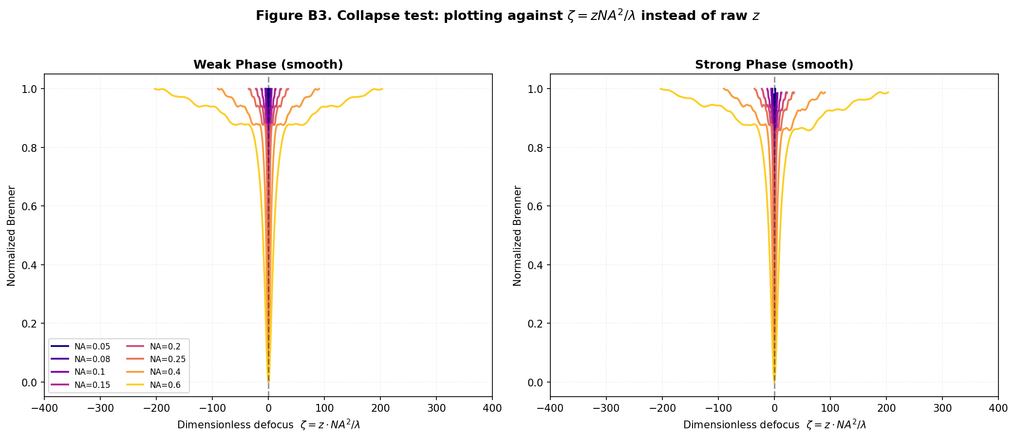
Figure 3. Every tested NA's Brenner curve collapses approximately onto one shape when plotted against the dimensionless coordinate zeta = z*NA^2/lambda, derived from the classical defocus aberration term (Goodman, 2017).

6.5 A proposed new connection: the Nyquist-matched NA is the autofocus-optimal NA
Section 4.2 above described two separately established 'NA matching' principles: illumination NA matched to objective NA for optimal DPC/WOTF phase transfer (Tian & Waller, 2015, and related work), and objective NA matched to camera Nyquist sampling for optimal resolution transfer (standard microscope design practice). We tested how the depth of the Brenner-curve null (its min/max ratio, our modulation-depth quantity) varies with NA directly, and found it is not monotonic: it deepens from low NA to an optimum, then shallows again at higher NA. A fine sweep located this optimum at NA = 0.208 (weak phase) and NA = 0.241 (strong phase) in our system -- both within a few percent of the 0.213 crossover NA at which the objective's diffraction-limited passband is exactly matched to the camera's own Nyquist sampling limit.
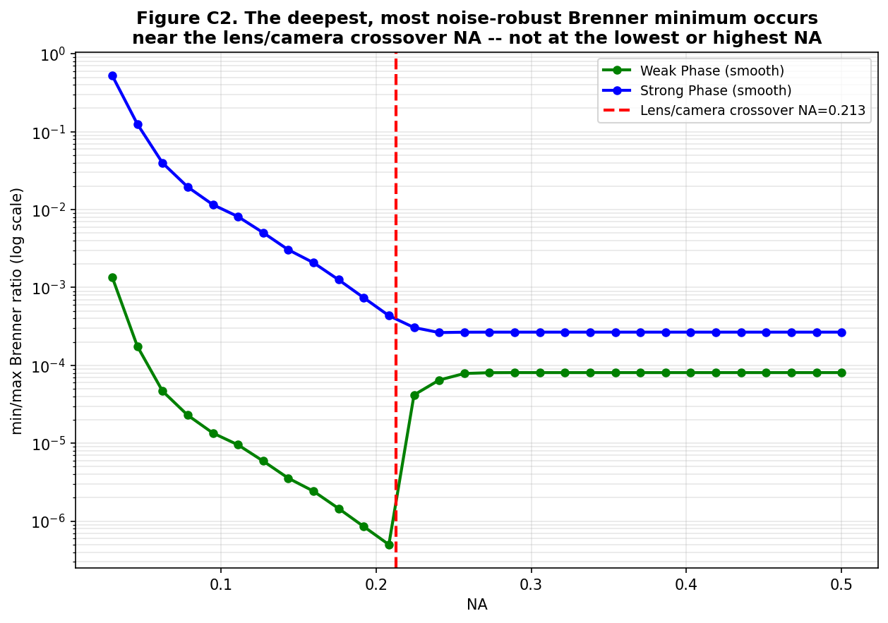
Figure 4. The deepest, most noise-robust Brenner minimum occurs almost exactly at the NA where the objective's diffraction limit matches the camera's Nyquist limit -- a connection between two previously separate 'NA matching' principles in the literature.
We present this as a specific, testable, and to our knowledge new proposal: that the well-known Nyquist-matching design rule for optimal resolution transfer is, for coherent phase-object imaging, simultaneously the design rule for optimal single-shot autofocus reliability. This connects two established principles from two different parts of the literature into a third consequence neither literature states.

7. Discussion: Toward a Unified Framework
Placed alongside the literature reviewed in Sections 3-4, our results suggest that the FPM field's various defocus-estimation strategies -- sharpness search, residual consistency, Zernike-mode fitting, hardware-assisted shift detection, and learned regression -- succeed or fail to the extent that they preserve or exploit deep modulation, not to the extent that they maximize raw visual contrast. Hardware-assisted methods (Section 3.4) sidestep the issue by measuring a geometric shift rather than a contrast level at all. Learned methods (Section 3.5) succeed because a trained regressor can exploit shallow, complex, and even sign-changing modulation patterns that a scalar greedy search cannot. Residual-consistency indices (Section 3.2) are, by construction, comparing measured to simulated LOW-resolution data at every angle rather than the sharpness of one high-resolution reconstruction, and may therefore have different, and to our knowledge uncharacterized, modulation-depth behavior of their own -- the single most direct piece of future work this review identifies.

8. Limitations and Future Scope
Combining the limitations explicitly stated across the reviewed literature with those of our own simulation study, we identify the following concrete directions:
- Direct, quantitative comparison of the residual-consistency autofocus index (Section 3.2) against a Brenner-gradient sharpness metric, under matched noise budgets and phase-object strengths, has not been done anywhere in the literature we reviewed and is a natural next experiment.
- Pan, Zuo, and Yao (2020) list noise, vignetting, and motion blur as unsolved 'system errors' in mainstream FPM reconstruction as of 2020; our modulation-depth framework offers a first-principles lens for re-examining specifically the noise item on this list as it pertains to defocus estimation, though vignetting and motion blur remain outside our present scope.
- A structurally different estimator -- solving for defocus directly from the Transport of Intensity Equation using a small number of intensity differences, in the spirit of the depth-from-defocus/TIE unification literature (Section 4.1) -- was motivated repeatedly by our results but not yet implemented; this is the most promising concrete next step identified by both our own work and, independently, by the pattern of successful learned methods in Section 3.5.
- Our proposed Nyquist-matched-NA autofocus optimum (Section 6.5) was demonstrated for one object family and one set of hardware parameters; testing it across a range of real optical systems and phase strengths is necessary before it can be stated as a general design rule.
- The learned single-shot methods surveyed in Section 3.5 report degraded accuracy at low NA (low-magnification objectives); whether this connects to the same modulation-depth argument we propose, or to a separate limitation of the learned feature representations used, is an open question raised directly by juxtaposing that literature with our own results.

9. Conclusion
Autofocusing in Fourier ptychographic microscopy has been engineered around, more often than it has been explained. This review traced that engineering across sharpness search, residual consistency, joint aberration fitting, hardware-assisted detection, and learned single-shot regression, and found a literature rich in working solutions but comparatively thin on a first-principles account of why phase objects make the simplest of those solutions -- a greedy sharpness search -- behave so differently from the ordinary, stained samples autofocus was originally designed for. Our own simulation work, read against this literature, converges on a single governing concept, modulation depth, that explains a metric-definition pitfall, a propagation sampling limit implicit but unaddressed in FPM's own extended-refocusing claims, the apparent conflict between our results and a leading learned-autofocus paper, and a new, specific, testable connection between two previously separate NA-matching principles in microscope design. We hope this review, and the modulation-depth framework it supports, gives the next piece of FPM autofocus engineering a foundation to build on rather than another workaround to add.

References
Brenner, J. F., Dew, B. S., Horton, J. B., King, T., Neurath, P. W., & Selles, W. D. (1976). An automated microscope for cytologic research. Journal of Histochemistry and Cytochemistry, 24, 100-111.
FPM-WSI: Fourier ptychographic whole slide imaging via feature-domain backdiffraction (2024). arXiv:2402.18270.
Goodman, J. W. (2017). Introduction to Fourier Optics (4th ed.). Macmillan Learning.
Guo, C., et al. (2020). OpenWSI: a low-cost, high-throughput whole slide imaging system via single-frame autofocusing and open-source hardware. Optics Letters, 45, 260-263.
High-resolution transport-of-intensity quantitative phase microscopy with annular illumination (2017). Scientific Reports 7.
Jiang, S., Liao, J., Bian, Z., Guo, K., Zhang, Y., & Zheng, G. (2018). Transform- and multi-domain deep learning for single-frame rapid autofocusing in whole slide imaging. Biomedical Optics Express, 9(4), 1601-1612.
Liao, J., et al. (2016, 2017). Rapid focus map surveying for whole slide imaging with continuous sample motion, and related single-frame autofocusing work. Optics Letters / Biomedical Optics Express.
Luo, Y., Huang, L., Rivenson, Y., & Ozcan, A. (2020). Single-shot autofocusing of microscopy images using deep learning. arXiv:2003.09585.
Matsushima, K., & Shimobaba, T. (2009). Band-limited angular spectrum method for numerical simulation of free-space propagation in far and near fields. Optics Express, 17(22), 19662-19673.
Ou, X., Zheng, G., & Yang, C. (2014). Embedded pupil function recovery for Fourier ptychographic microscopy. Optics Express, 22, 4960-4972.
Pan, A., Zuo, C., & Yao, B. (2020). High-resolution and large field-of-view Fourier ptychographic microscopy and its applications in biomedicine. Reports on Progress in Physics, 83, 096101.
Pinkard, H., Phillips, Z., Babakhani, A., Fletcher, D. A., & Waller, L. (2019). Deep learning for single-shot autofocus microscopy. Optica, 6(6), 794-797.
Price, J. H., et al. Autofocus system for scanning microscopy (having a volume image formation). US Patents 5,790,710 and 5,932,872.
Song, P., et al. (2019). Full-field Fourier ptychography (FFP): spatially varying pupil modeling and its application for rapid field-dependent aberration metrology. APL Photonics, 4, 050802.
Sun, Y., Duthaler, S., & Nelson, B. J. (2004). Autofocusing algorithm selection in computer microscopy. Microscopy Research and Technique.
Teague, M. R. (1983). Deterministic phase retrieval: a Green's function solution. Journal of the Optical Society of America, 73, 1434-1441.
Tian, L., & Waller, L. (2015). Quantitative differential phase contrast imaging in an LED array microscope. Optics Express, 23(9), 11394-11403.
Depth from Defocus as a Special Case of the Transport of Intensity Equation. IEEE conference literature.
Voelz, D. (2011). Computational Fourier Optics: A MATLAB Tutorial. SPIE Press.
Zhang, S., Ni, Y., Deng, W., & Sun, M. (2024). Sharpness-Statistic Based Autofocus Algorithm for Fourier Ptychographic Microscopy. SSRN preprint 5033007.
Zheng, G., Horstmeyer, R., & Yang, C. (2013). Wide-field, high-resolution Fourier ptychographic microscopy. Nature Photonics, 7, 739-745.
Zheng, G., Shen, C., Jiang, S., Song, P., & Yang, C. (2021). Concept, implementations and applications of Fourier ptychography. Nature Reviews Physics, 3, 207-223.
Zheng, G., Yang, C., et al. Fourier ptychographic imaging systems, devices, and methods (patent family, e.g. US 9,892,812; US 10,679,763; US 12,237,094).

